**NATIONAL INSTITUTE OF TECHNOLOGY SILCHAR**

**Cachar, Assam**

**B.Tech. IVth Sem**

**Subject Code:** CS215

**Subject Name:** Signals and Data Communication

**Submitted By:**

Name : Subhojit Ghimire

Sch. Id. : 1912160

Branch : CSE – B

1. **Suppose input to a system is x[n] = u[n – 1] – u[n – 5] whose impulse response is h[n] = tri $\left(\frac{n-6}{4}\right)$ where the function “tri” is defined as,**

$$tri \left[m\right]= \left\{\begin{aligned}1- \left|m\right| ,\left|m\right|<1 \\ 0 , otherwise \end{aligned}\right.$$

**Plot the analytical expression and output of “conv” function of MATLAB.**

* **AIM: To PLOT AN ANALYTICAL EXRESSION FOR A FUNCTION “TRI” AND OUTPUT OF “CONV”.**

**THEORITICAL BACKGROUND:**

**Impulse Response:** An impulse response is the reaction of any dynamic system in response to some external change.

**Convolution:** Convolution is a mathematical operation on two functions (f and g) that produces a third function ( ) that expresses how the shape of one is modified by the other. The “conv” function only works on discrete data.

**Unit Step Function:** The unit step function is the sum of infinite shifted unit impulse functions.

**METHODOLOGY:**1. The “heaviside” function is used to simulate the unit step function.  
2. The “conv” function is used to generate a vector of the convolution.

**CODE:**

syms n x(n) h(n);

x(n) = heaviside (n-1) - heaviside (n-5);

h(n) = triangularPulse ((n-6)/4);

range = [-100:1:100];

xVec = double(x(range));

hVec = double(h(range));

yVec = conv(xVec, hVec, 'same');

subplot (3,1,1);

stem(range, xVec);

xlabel('Input Signal');

pbaspect([2.5, 1, 1]);

axis([0, 16, 0, 1.5]);

subplot (3,1,2);

stem(range, hVec);

xlabel('Impulse Response');

pbaspect([2.5, 1, 1]);

axis([0, 16, 0, 1.5]);

subplot (3,1,3);

stem(range, yVec);

xlabel('Output Signal');

pbaspect([2.5, 1, 1]);

axis([0, 16, 0, 3.5]);

**INPUT DATA DESCRIPTION:**The given functions x[n] and h[n] were passed through values ranging from -100 to 100 at the interval of 1.

**RESULT:**

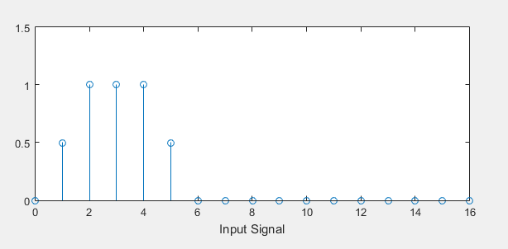

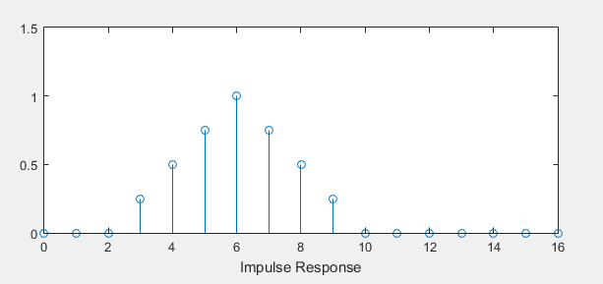

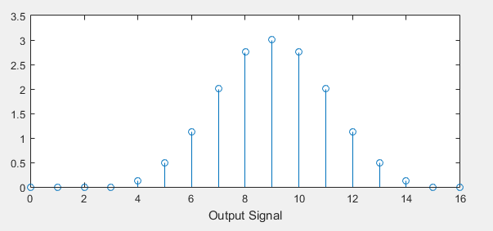

**CONCLUSION/DISCUSSION:**The output of “conv” function was obtained to be a pulse.

1. **The unit-step response of a discrete-time LTI system is,**

**s[n] = 2[(–0.5)n – 1] u[n]**

* 1. **Using this information compute & plot the impulse response of the system, h[n].**
  2. **Compute & plot the response of the LTI system to ramp signal, x[n] = nu[n], input using MATLAB. Use MATLAB function “filter” and superposition.**

* **AIM: TO PLOT THE IMPULSE RESPONSE OF THE LTI SYSTEM USING “FILTER” FUNCTION AND SUPERPOSITION.**

**THEORITICAL BACKGROUND:**

**Unit Step Function:** The unit step function is the sum of infinite shifted unit impulse functions.

**Discrete-time Systems:** A discrete-time system processes a given input sequence x[n] to generate an output sequence y[n] with more desirable properties.

**LTI-System: A l**inear time-invariant system is the one that produces an output signal from any input signal subject to the constraints of linearity and time-invariance.

**Impulse response:** An impulse response is the reaction of any dynamic system in response to some external change.

**Filtering:** Filtering a signal refers to rectifying its output into a continuous signal that reasonably approximates the original signal.

**METHODOLOGY:**1. The impulse response is computed form the unit response.  
2.The impulse function and convolution are plotted.

**CODE:**

close all;

clear all;

clc;

syms n s(n) h(n) x(n);

s(n) = 2*((-0.5)^n - 1)*heaviside(n);

h(n) = s(n) - s(n-1);

x(n) = n*heaviside(n);

range = [-100:1:100];

sVec = double(s(range));

hVec = double(h(range));

xVec = double(x(range));

yVec = conv(xVec, hVec, 'same');

subplot (3,1,1);

stem(range, sVec);

xlabel('Unit response');

pbaspect([2.5, 1, 1]);

axis([-2.5, 10.5, -3.5, 0]);

subplot (3,1,2);

stem(range, hVec);

xlabel('Impulse response');

pbaspect([2.5, 1, 1]);

axis([-2.5, 10.5, -3.5, 2]);

subplot (3,1,3);

stem(range, yVec);

hold on;

windowSize = 2;

b = (1/windowSize)*ones(1, windowSize);

yVecFiltered = filter(b, 1, yVec);

plot(range, yVecFiltered, 'g');

hold off;

xlabel('Convolved Signal and Filtered Counterpart');

pbaspect([2.5, 1, 1]);

axis([-2.5, 10.5, -20, 0]);

**INPUT DATA DESCRIPTION:**The unit step response s[n] and ramp signal x[n] were passed through the values ranging from -100 to 100 at the interval of 1.

**RESULT:  
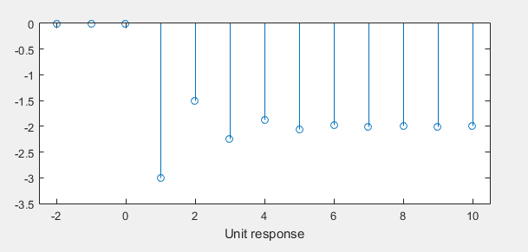**

**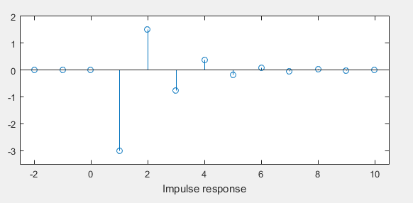  
  
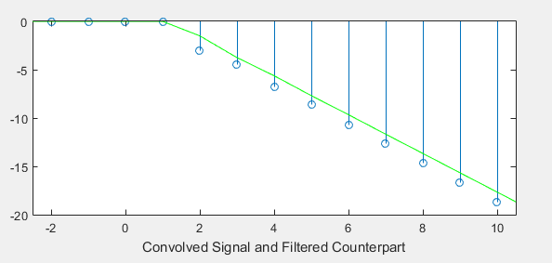**

**CONCLUSION/DISCUSSION:**The resulting output is a scaled version of the input.